**Lab Task 6**

**My Application: Quiz**

**Objective:**

* Apply radio button
* Apply select group

1. Create an interface shown as below:

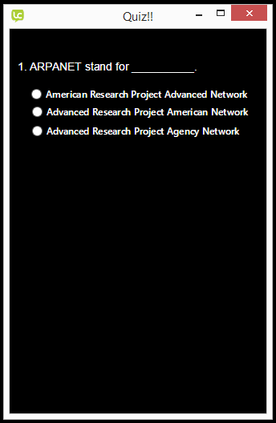

1. Add the following objects:

* Label 1 : ARPANET stand for ___________ -> name: lQ1
* Radio button: American Research….. -> name: r1
* Radio button: Advanced Research….. -> name: r2
* Radio button: Advanced Research….. -> name: r3

1. Right click on radio button “r1” and select Edit Script

**on** mouseUp

**answer** "That's Right. Congratulation!!" with "Okay"

**end** mouseUp

1. Right click on radio button “r2” and select Edit Script

**on** mouseUp

**answer** "That's Wrong. Please try again" with "Okay"

**end** mouseUp

1. Right click on radio button “r3” and select Edit Script

**on** mouseUp

**answer** "That's Wrong. Please try again" with "Okay"

**end** mouseUp

1. Select all radio button, then Object -> Group selected
2. Add the following code for the object group

|  |
| --- |
| **on** mouseUp  **if** the hilite of button "r1" **then**  **end** **if**  **if** the hilite of button "r2" **then**  **end** **if**  **if** the hilite of button "r3" **then**  **end** **if**  **end** mouseUp |

1. Finally open the standalone settings for your app. Click File -> Standalone Application Settings.
2. Now save the app as a standalone. Click File -> Save as Standalone Application.
3. Go to the folder where you saved your app and open it. You may choose one either Windows, Mac or Linux depending on the machine you are on, select an app to run.
4. Now you have an app that runs on its own on your desktop.

**Tutorial Question:**

Edit the task given above by adding one more question with choice of answers. Then, add in Calculate and Reset button into your design. Calculate button will calculate and display the marks achieved for the quiz while reset button will reset all radio button again. User will get 2 marks for each correct answers. Display the marks in message box.